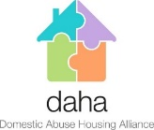

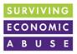


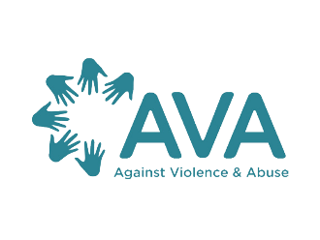

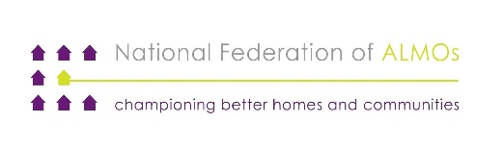
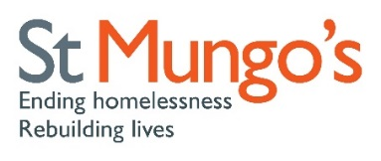
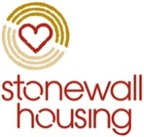




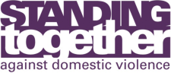





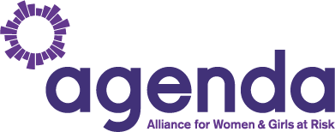
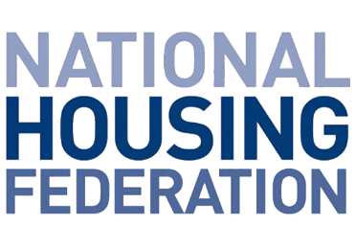

UK Election 2019 - Domestic Abuse and Housing Manifesto

Domestic abuse is, by its very nature, a housing issue and a core driver of women’s homelessness. A survivor’s ability to access safe housing and other economic resources is a key factor in her decision about whether she can leave. Over half of women killed by men in 2017 were killed in their own home, or the home they shared with the perpetrator. The Home Office estimate that domestic abuse cost the government half a billion in housing costs in just one year.

As domestic abuse and other forms of violence against women and girls (VAWG) typically occur within the home, the response from the housing sector to tackling these crimes is crucial in delivering the right response to survivors. Over the past two years, the National Housing and Domestic Abuse Policy and Practice Group, led by the Domestic Abuse Housing Alliance (DAHA), has worked together to improve and influence policy and practice on housing and domestic abuse in England. Together we want to see a ‘whole housing approach’ to this devastating crime that delivers a full range of safe housing options to survivors and their children escaping abuse.

Following the UK election on 12th December 2019, we are calling on the new government to:

- Secure funding: guarantee a sustainable funding future for all specialist domestic abuse and violence against women and girls services– both those that help them stay safely in their own homes and those that help them escape - to ensure no survivor is turned away from the specialist life-saving support they need.

- Settled homes: pledge to build at least 90,000 social-rent homes a year over the course of the next parliament to increase the alternative housing options open to survivors needing to flee abuse and build a safe and settled future.

- Housing rights: amend homelessness legislation to give automatic priority need for rehousing for all homeless survivors of domestic abuse in England, ban local connection restrictions for those that have to flee outside of their area to be safe, and reform tenancy laws which create major barriers to leaving safely.

- Economic stability: ensure that our social security system enables survivors to access the funds they need to escape abuse and build a safe, independent and stable future by ensuring housing benefit can meet the costs of accommodation, and adapting universal credit and other welfare reforms that create barriers to leaving and which facilitate economic abuse.

- Accessible services for migrant survivors - ensure that women with insecure immigration status can access their rights to refuge and safe accommodation in reality by extending the eligibility and time-limit for the Domestic Violence Rule and Destitution Domestic Violence Concession.

- A ‘whole housing’ approach - deliver a coordinated approach to housing, domestic abuse and VAWG with joined up strategies at national and local levels encompassing all housing tenures.

Femicide Census (developed by Karen Ingala Smith and Women’s Aid Federation of England working in partnership, with support from Freshfields Bruckhaus Deringer LLP and Deloitte LLP). (2018) The Femicide Census: 2017 findings. Annual Report on cases of Femicide in 2017. Published online: Karen Ingala Smith and Women’s Aid
Oliver, R., Alexander, B., Roe, S. & Wlasny M. (2019) The economic and social costs of domestic abuse. Published online: Home Office
67% of the women supported by Women’s Aid’s No Woman Turned Away project in 2016 who had no recourse to public funds were not eligible for the DDVC because they were not on a spousal visa (Women’s Aid, Nowhere to Turn: Findings from the First Year of the No Woman Turned Away Project, 2017

